2017-11-20 Code Dev Notes

Continuation of

***Google Drive\FusionPBX\Code Development\2017-11-19 Code Dev Notes.docx***

**MUST READ Simple guide to forks in GitHub and Git**

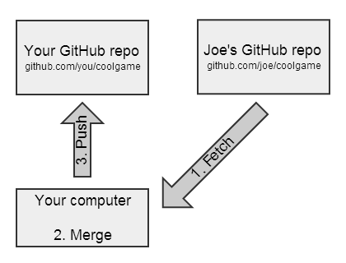<http://www.dataschool.io/simple-guide-to-forks-in-github-and-git/>

Figure 2 - Synching a Fork

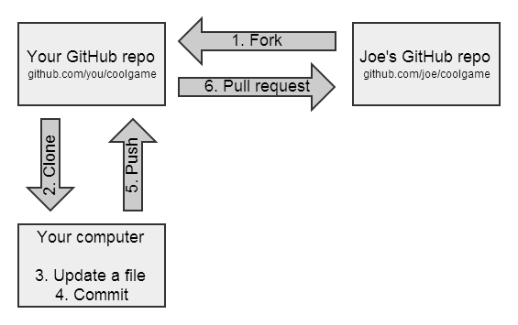

Figure - Forking and Updating a Repo

**git status**

On branch yealinktemplates

Your branch is up-to-date with 'origin/yealinktemplates'.

nothing to commit, working directory clean

**git checkout master**

Switched to branch 'master'

Your branch is up-to-date with 'origin/master'.

**git status**

On branch master

Your branch is up-to-date with 'origin/master'.

nothing to commit, working directory clean

**git checkout spectralink**

Branch spectralink set up to track remote branch spectralink from origin.

Switched to a new branch 'spectralink'

**git status**

On branch spectralink

Your branch is up-to-date with 'origin/spectralink'.

nothing to commit, working directory clean

*https://github.com/TekMason/fusionpbx* says master is  
“This branch is 2 commits ahead, 4 commits behind fusionpbx:master.”

Summary of a sync

1. Fetch changes from fusionpbx/fusionpbx
2. Merge the changes into TekMason/fusionpbx  
   *Note: Steps 1 and 2 are often combined into a single Git operation called a "pull."*
3. Push the updates to GitHub repo TekMason/fusionpbx

References

[Syncing a fork](https://help.github.com/articles/syncing-a-fork/) > [Configuring a remote for a fork](https://help.github.com/articles/configuring-a-remote-for-a-fork/)

**git remote –v**

origin https://github.com/TekMason/fusionpbx.git (fetch)

origin https://github.com/TekMason/fusionpbx.git (push)

**git remote add upstream https://github.com/fusionpbx/fusionpbx.git**

**git remote -v**

origin https://github.com/TekMason/fusionpbx.git (fetch)

origin https://github.com/TekMason/fusionpbx.git (push)

upstream https://github.com/fusionpbx/fusionpbx.git (fetch)

upstream https://github.com/fusionpbx/fusionpbx.git (push)

Back to [Syncing a fork](https://help.github.com/articles/syncing-a-fork/)

**git fetch upstream**

remote: Counting objects: 17, done.

remote: Compressing objects: 100% (6/6), done.

remote: Total 17 (delta 11), reused 11 (delta 10), pack-reused 1

Unpacking objects: 100% (17/17), done.

From <https://github.com/fusionpbx/fusionpbx>

* [new branch] 4.0 -> upstream/4.0

* [new branch] 4.2 -> upstream/4.2

* [new branch] master -> upstream/master

**git checkout master**

Switched to branch 'master'

Your branch is up-to-date with 'origin/master'.

**git merge upstream/master**

Merge made by the 'recursive' strategy.

app/extensions/extensions.php | 41 +++++++++++++++++++++++++----------------

app/xml_cdr/xml_cdr_statistics_inc.php | 3 ++-

2 files changed, 27 insertions(+), 17 deletions(-)

**git push**

My repo says synch process didn't bring my github repo in synch with fusionpbx/fusionpbx. It says "This branch is 3 commits ahead of fusionpbx:master."

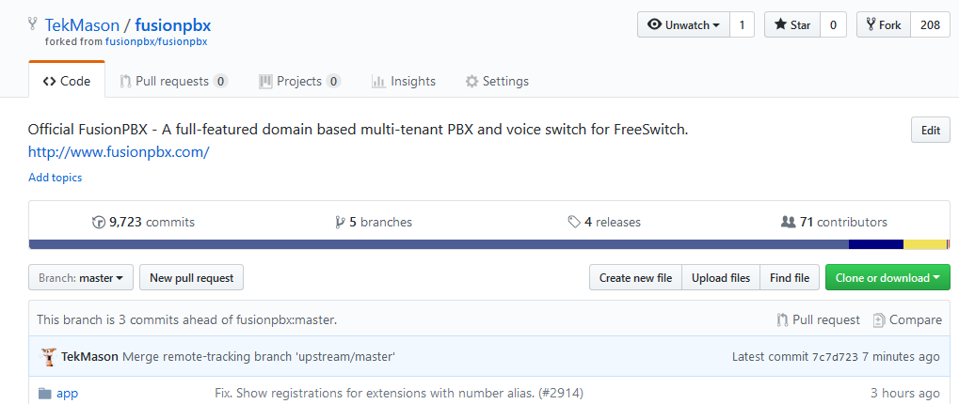

From Hopper

<https://www.atlassian.com/git/tutorials/comparing-workflows>

<https://www.atlassian.com/git/tutorials/comparing-workflows/feature-branch-workflow>

## 20:30

Mark did a new commit to fusion/fusion

tekmason/fusion master now shows:

*This branch is 3 commits ahead, 1 commit behind fusionpbx:master.*

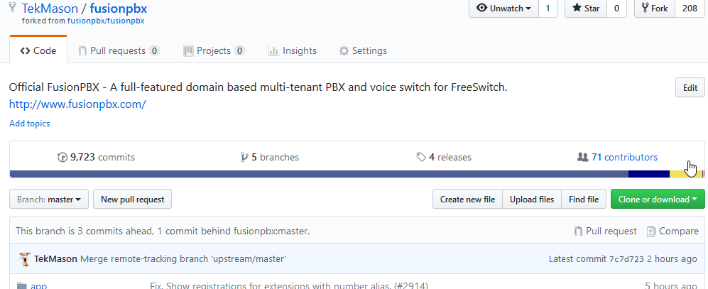

Start the synch process again.

**git status**

On branch master

Your branch is up-to-date with 'origin/master'.

nothing to commit, working directory clean

**git fetch upstream**

remote: Counting objects: 16, done.

remote: Compressing objects: 100% (14/14), done.

remote: Total 16 (delta 3), reused 0 (delta 0), pack-reused 0

Unpacking objects: 100% (16/16), done.

From https://github.com/fusionpbx/fusionpbx

eea1f54..f8284ca 4.2 -> upstream/4.2

9cb0e37..ef3f99a master -> upstream/master

**git checkout master**

Already on 'master'

Your branch is up-to-date with 'origin/master'.

**git merge upstream/master**

Merge made by the 'recursive' strategy.

resources/templates/provision/snom/7xx/{$mac}.xml | 10 +++++-----

1 file changed, 5 insertions(+), 5 deletions(-)

**git push**

warning: push.default is unset; its implicit value has changed in

Git 2.0 from 'matching' to 'simple'. To squelch this message

and maintain the traditional behavior, use:

git config --global push.default matching

To squelch this message and adopt the new behavior now, use:

git config --global push.default simple

When push.default is set to 'matching', git will push local branches

to the remote branches that already exist with the same name.

Since Git 2.0, Git defaults to the more conservative 'simple'

behavior, which only pushes the current branch to the corresponding

remote branch that 'git pull' uses to update the current branch.

See 'git help config' and search for 'push.default' for further information.

(the 'simple' mode was introduced in Git 1.7.11. Use the similar mode

'current' instead of 'simple' if you sometimes use older versions of Git)

Username for 'https://github.com': TekMason

Password for 'https://TekMason@github.com':

Counting objects: 9, done.

Delta compression using up to 4 threads.

Compressing objects: 100% (8/8), done.

Writing objects: 100% (9/9), 1.21 KiB | 0 bytes/s, done.

Total 9 (delta 6), reused 0 (delta 0)

remote: Resolving deltas: 100% (6/6), completed with 6 local objects.

To https://github.com/TekMason/fusionpbx.git

7c7d723..ba3fe12 master -> master

tekmason/fusion master now shows:  
*This branch is 4 commits ahead of fusionpbx:master.*

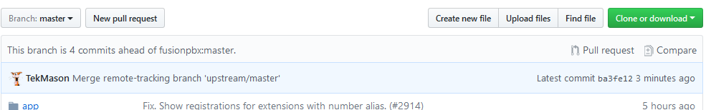

Compare shows

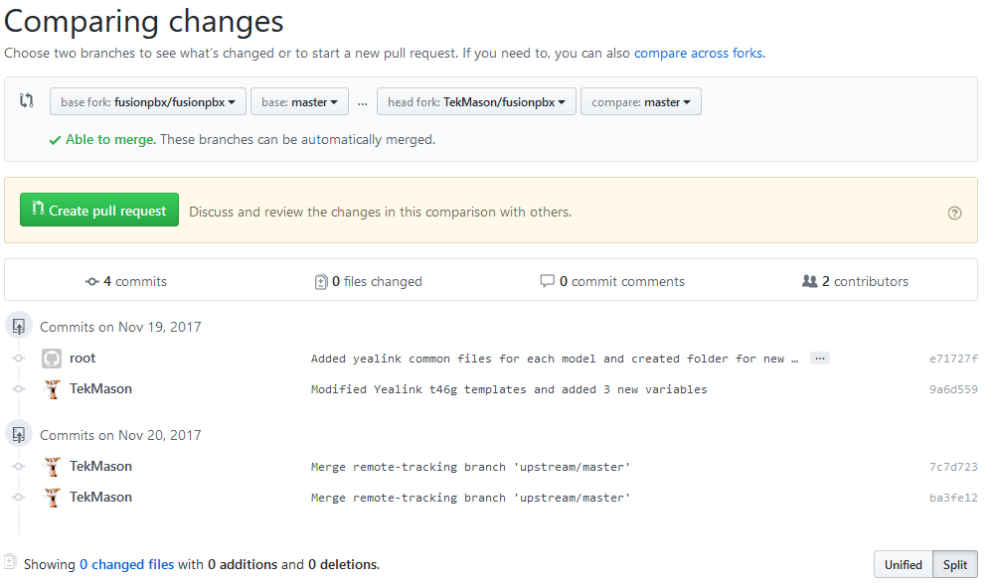

The detailed steps I have done to do a sync are here <https://github.com/TekMason/gitworkflow/raw/master/2017-11-20%20Code%20Dev%20Notes.docx>